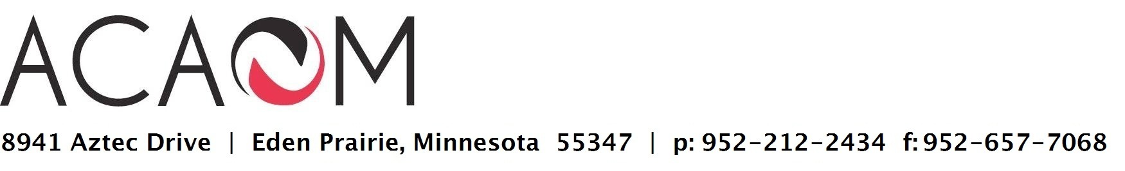

May 23, 2014

Ms. Ashley Higgins
  - Department of Education 1990 K Street NW, Room 8031 Washington, DC 20006-­‐8502

Re: Comments on the Notice of Proposed Rulemaking on Gainful Employment, Docket Number: ED-­‐2014-­‐OPE-­‐0039

Dear Ms. Higgins:

On behalf of the Commissioners of the Accreditation Commission for Acupuncture & Oriental Medicine (ACAOM), and in partnership with the Council of Colleges of Acupuncture & Oriental Medicine (CCAOM), the National Certification Commission for Acupuncture & Oriental Medicine (NCCAOM) and the American Association of Acupuncture & Oriental Medicine (AAAOM), we write to offer comments on the Notice of Proposed Rulemaking (NPRM) on Gainful Employment, Docket Number: ED-­‐2014-­‐OPE-­‐0039. ACAOM is approved by the USDE to accredit Masters and Doctoral degree programs in our field. Collectively, we represent over 33,000 students and graduate acupuncturists in the United States, and 56 colleges of Acupuncture & Oriental Medicine. Roughly half of these colleges are for-­‐profit, which would be unfairly jeopardized by the application of these regulations in their current proposed form.

Overview:

We believe the proposed gainful employment rules should not apply to graduate medical programs that lead to state licensure in the healthcare professions.

    - The need for these programs, including Acupuncture & Oriental Medicine, is clearly established by state law, and in some cases federal law.

    - Implementing the 3-­‐year rule instead of a more realistic 5 or 7 year time period for the debt ratios fails to consider the time necessary to build a professional healthcare practice in the rapidly changing healthcare marketplace. Most graduate programs would fail under the overbroad ratios that are not tailored to these longer healthcare programs, and will

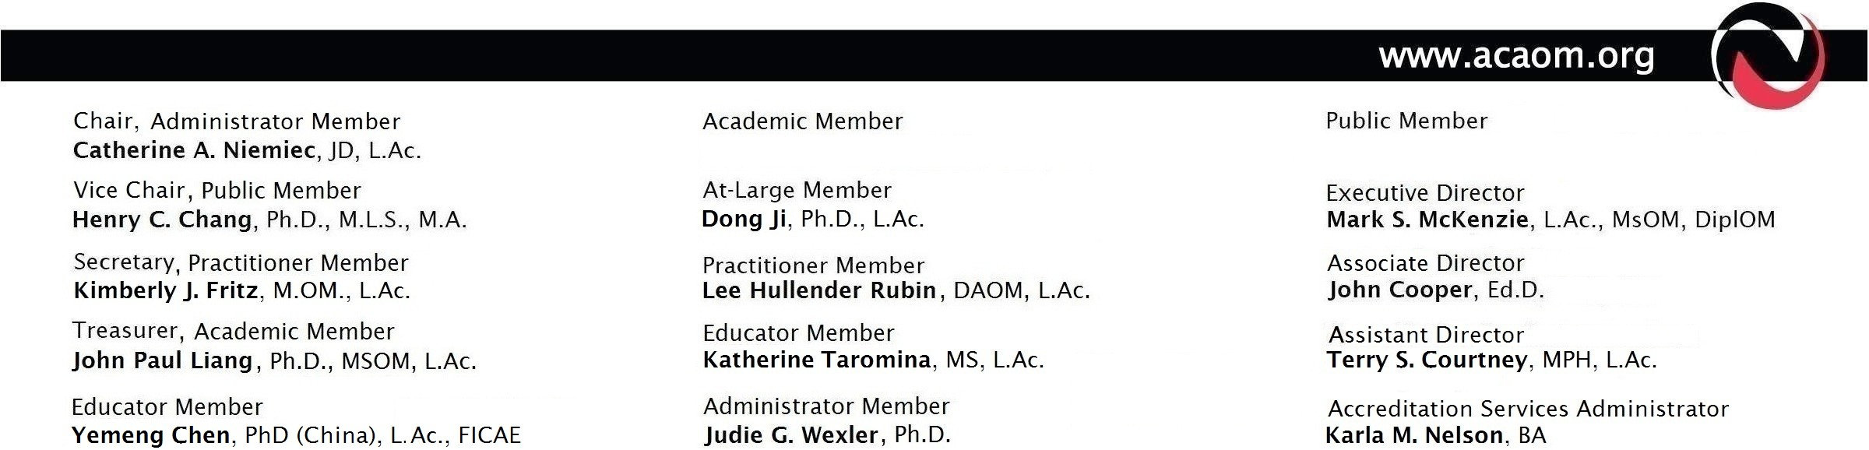

ultimately restrict choice, reduce access and increase costs in direct contrast to the goals of the Affordable Care Act. (See attachment)

    - The proposed rules do not account for the valid and much-­‐needed choice of healthcare providers to deliver care to low-­‐income populations.

    - The proposed rules do not account for individuals that choose to pursue part-­‐time medical practices while supporting their own families.

    - The proposed rules appear to disincentive minorities and low-­‐income students from pursuing these medical careers, thereby restricting access to healthcare and education to the wealthier students.

    - The proposed rules are discriminatory in that they hold for-­‐profit medical education institutions to a different standard than non-­‐profit medical institutions without a clear basis. We have found no significant difference in default rates, graduation rates or examination board scores when comparing results from for-­‐profit to non-­‐profit institutions. The for-­‐profit institutions that we accredit are able to provide these non-­‐ traditional medical degrees, and the needed flexibility, innovation and creativity in delivering this type of education to those not able to attend mainstream institutions.

    - The overall effect of the proposed regulations limits financial aid available through for-­‐ profit non-­‐traditional healthcare institutions, restricting student choice as to where they can go to school, what they can study and what careers they can enter. Importantly, these rules may ultimately have the unintended consequence of destroying new and emerging complementary healthcare training programs and related job categories.

In our review, accredited institutions that are compliant with our standards have been adequately and sufficiently preparing students in this field. The primary determinant for success in earnings is dependent upon the students who make their own personal choices as to the type of practice, which economic region or territory to practice in, and whom to treat.

We propose that, in addition to an exemption for graduate healthcare programs, alternate metrics such as default rates, graduation rates and board examination scores be used to demonstrate gainful employment potential for graduates of medical programs, including Acupuncture and Oriental Medicine, that lead to state licensure in the healthcare professions. By denying or placing for-­‐profit AOM colleges on provisional certification for being out of compliance with the proposed gainful employment metric (primarily due to our small size), these AOM colleges would be unable to provide the type of healthcare education needed to respond to the changing market, namely the public demand for safer, cost-­‐effective, and more effective healthcare.

Thank you for considering our concerns and for looking beyond the initial proposed regulations to the ultimate impact on the public, both to students seeking to move into Acupuncture & Oriental Medicine as a career, and to the patients who are able to recover from illness using this internationally accepted, oldest form of medicine in the world.

Sincerely,

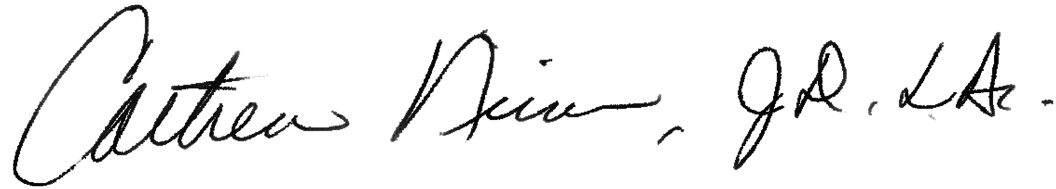

Catherine Niemiec, JD, L.Ac.
Chair, Accreditation Commission for Acupuncture & Oriental Medicine

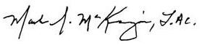

Mark S. McKenzie, LAc MsOM DiplOM
Executive Director, Accreditation Commission for Acupuncture & Oriental Medicine

cc:
Lixin Huang, L.Ac., President David Sale, JD, Executive Director, CCAOM

Kory Ward Cook, CEO NCCAOM

Don Lee, L.Ac., DNBAO, AOS, CSCS, President Michael Jabbour, L.Ac, CSP, MS, President Emeritus AAAOM

Re: Comments on the Notice of Proposed Rulemaking on Gainful Employment, Docket Number: ED-­‐2014-­‐OPE-­‐0039

ATTACHMENT:

The following provides additional support for our request for an exemption for graduate medical institutions, and for the use of alternate measures of gainful employment.

- Bias against Graduate Healthcare Programs

We understand the importance of supporting program integrity and ensuring gainful employment, yet these proposed regulations are negatively biased against longer term and costlier healthcare programs. Students in these programs have to borrow more in the aggregate, despite the fact that their earnings differential from those with lesser degrees does not emerge until after the first three years of graduation. In most cases, it takes at least 5 years to achieve the higher rates of income that are able to pay down tuition debt more readily. The proposed regulations are based on the premise that the gap in earnings for the first 3 years is about the same as the gap in later years. While this may be true for those with a high school degree, this does not hold true for masters and doctoral degree students whose level of earnings increases significantly during the first 10 years after graduation.

The debt-­‐to-­‐earnings and debt-­‐to-­‐discretionary income ratios as metrics for institutions to qualify as fully eligible should not apply to graduate medical education. These metrics put a majority of graduate medical education programs in the restricted category. In addition, the gainful employment metric does not allow for students to be considered in repayment totals if the student chooses lower paying jobs in social service fields, if working part-­‐time as a parent, or in temporary deferment or forbearance, despite Congressional support of these means of repayment for graduates. The argument that “academic programs which produce large numbers of students who are forced to rely on these safety net provisions due to large debts and low incomes may not be serving students well” should not apply in this current economic climate. Moreover, colleges cannot be held responsible for this metric when overall economic forces generate a poor job market overall. This negatively skews metric results for healthcare institutions, particularly for smaller programs with small student populations, many of which are excellent and produce exceptional healthcare providers.

- Impact on American Healthcare Provided by Acupuncture & Oriental Medical (AOM) Graduate Programs

More and more studies have shown that acupuncture (and its related modalities of herbal medicine, nutrition, exercise and bodywork) provide significant healthcare benefits, many of which surpass conventional Western medical healthcare. Acupuncture is more effective, safer with few to no side effects, more cost-­‐effective, and desired by the public. The World Health

Organization cites over 43 conditions treatable by acupuncture.* The US military now uses acupuncture for soldiers and veterans to combat PTSD and pain. Studies by the Institute of Medicine (2005 Report) show that there are now more visits to complementary and alternative healthcare (CAM) providers (such as acupuncturists) than to primary care physicians. At the 2009 IOM Summit on Integrative Medicine, CAM was cited as an integral part of healthcare reform and a solution to our healthcare crisis (acupuncturists play a large part in helping to meet the need for CAM and integrative healthcare). Indeed, this trend towards increased use of and referral for acupuncture shows no signs of slowing. The need and demand for Acupuncture & Oriental Medicine (AOM) is not met by any other medical field that might only offer introductory training of a couple hundred hours, as compared to comprehensive training of 3-­‐4 years for an entry-­‐level, independent AOM medical provider. (See also: http://www.ccaom.org/downloads/CCAOM_KnowYourAcu.pdf)

The field of Acupuncture & Oriental Medicine (AOM) has been growing over the past 20 years and is comprised of 56 smaller institutions with 70 campuses ranging from 30 to 500 students at various locations throughout the United States, approximately half of which are for-­‐profit. Since AOM is a specialty field providing the highest training in this unique medicine, AOM colleges are most likely to be negatively impacted by a skewed gainful employment metric.

More specifically, most of our colleges will not qualify as “fully eligible” using the debt to earnings ratio because the numerator is too small. Not enough students would have paid down their loans in the first 3 years. Our colleges also won’t qualify as “fully eligible” using the debt to discretionary income ratio because the math only works for loan amounts less than $20,000, and most of our students will borrow over $60,000. Assuming the average loan amount of $60,000 over 10 years at 7%, most AOM colleges could only qualify as “fully eligible” using the 8% of total income Passing score if it can be shown that our graduates make an average annual income greater than $80,000 for the first 3 years. For example, if our average graduate borrows only $40,000 instead of the permitted $60,000, then their average annual income would only have to be $53,000 for our colleges to qualify as “fully eligible” under the 8% Passing score. Ultimately, the majority of our for-­‐profit colleges will have to be classified as “restricted eligibility”, which will require our colleges to warn applicants that they may not be able to meet their loan obligations based on the current placement and salary of our graduates. (Arguably, this warning should be required of all for-­‐profit and non-­‐profit colleges, public and private, for all careers, given market demand and the current economy.) Of course, the student can still borrow the maximum after an institution’s warning.

How our colleges are permitted to show gainful employment, e.g. using a 3-­‐year scale instead of our recommended 5-­‐7 year scale, will drastically affect whether or not our colleges are “fully eligible”. Current data from payscale.com shows that acupuncturists with less than 1 year of service earn a median salary of $45,000, while acupuncturists with 20 years or more experience earn a median salary of $122,500. Many colleges report graduate earnings that exceed those numbers. The Bureau of Labor Statistics has categorized Acupuncturists with “Other Health Diagnosing and Treating Practitioners” (since it is a relatively new field), and shows a median annual wage of $65,220, with a high of $133,500 and a low of $35,990. According to the BLS,

acupuncturists typically charge between $40 and $70 per one-­‐hour session. At this rate, an acupuncturist who works with as few as six people daily would gross in excess of $100,000 per year. However, it takes time to build the practice that reaches this level, and by choice, many acupuncturists also choose to offer lower rates to serve a low-­‐income population and/or work part-­‐time if they are also the primary child-­‐care provider in one’s family. Employment by traditional hospitals and clinics is still developing and may also only be part-­‐time until the practice fully develops.

There are several factors which account for the variance in revenue earned: location of practice, the number of people seeking treatments in the locality, number of patients the practitioner chooses to treat on an hourly/daily basis, amount the practitioner chooses to charge per patient, earnings from the sale of herbal or other retail products, the state in which they practice (in some states, acupuncture is more widely accepted, and earnings are higher if states regulate practitioners), whether they accept insurance and what the reimbursement rate is, whether they have employees or staff, and type of practice (sole proprietor, partnership, group, employee of a hospital or clinic, etc.). Flexibility in practice allows for part-­‐time work to support family income, or disabled practitioners to create a more manageable practice.

In a 2008 survey by the NCCAOM, the national certification agency for the profession, respondents indicated they had spent an average of $55,984 to $100,000 for their student loans, depending on amount borrowed. Average debt load was $45,891 (mean debt level for all respondents) with an average gross income being under $60,000 for 70% of respondents. A Pearson Chi-­‐Square analysis revealed that gross annual income was significantly related to hours worked and years in practice, with those who received their certification in the last 5 years earning less (80% earned less than
$60,000 and 15% earned up to $120,000), and the highest earning group being those who received their certification in the last 11-­‐15 years.

While it is true that many graduates have initial difficulty getting started in their practices, this is often the case as well with other developing medical professions (osteopath, naturopaths, chiropractors). Our AOM colleges are responding by providing even further education in practice management while simultaneously opening doors to employment opportunities beyond the initial and traditional field of sole practice. While there may be claims that acupuncturists cannot earn enough money, many of our graduates eventually are able to earn six-­‐figure incomes by their 10th year of practice, with traditional and community style practices. Yet this is not taken into account by the gainful employment rules, most likely resulting in dire consequences for most of our colleges, the entire for-­‐profit sector.

- The Discriminatory Impact of the Ability to Limit Loan Eligibility

The argument that for-­‐profit colleges are fundamentally different from non-­‐profit simply because their owners reap personal financial gain if the institution grows or profits does not justify these regulations. Indeed, we have seen many for-­‐profit owners have lower salary ranges and distributions because the smaller colleges operate with tight, limited budgets. In a May 16, 2014

article by the Chronicle of Higher Education, the pay salaries for executive compensation at public institutions in most cases are grossly inflated for the positions, with some executives earning as much as several million dollars. **

The overall effect of the proposed regulations limits financial aid available through for-­‐profit healthcare institutions, restricting student choice as to where they can go to school, what they can study and what careers they can enter. Only those who are wealthy would be able to afford to go to certain, unique educational programs, such as those offered through the Acupuncture & Oriental Medicine (AOM) colleges, or other complementary and alternative healthcare institutions. For-­‐profit institutions are able to provide these non-­‐traditional medical degrees, and the needed flexibility, innovation and creativity in delivering this type of education to those not able to attend mainstream institutions. These proposed regulations will make it harder for employers to find qualified and skilled workers, and to provide the supportive healthcare needed to meet our growing population's needs. It may also ultimately have the unintended consequence of destroying whole fields of healthcare and job categories.

Moreover, this singling out of for-­‐profit institutions of higher education in the medical healthcare field is discriminatory. All higher education medical programs, whether public or private, for profit or non-­‐profit, engender high debt loads. All of these programs should be held to the same standard of reminding potential students to consider the seriousness of their career undertaking and the long-­‐term debt involved.

By denying or placing for-­‐profit graduate medical AOM colleges on provisional certification for being out of compliance with the proposed gainful employment metric (primarily due to their small size), these AOM colleges would be unable to provide the type of healthcare education needed to respond to the changing market, namely the public demand for safer, cost-­‐effective, and more effective healthcare.

*Acupuncture has been used as an effective medical modality for over 2000 years. It has been recognized by the World Health Organization to treat over 300 conditions. In the US, people commonly seek treatment for the following conditions:
- Digestive disorders: gastritis, colitis and hyperacidity, spastic colon, constipation, diarrhea, nausea, weight loss.
- Respiratory disorders: allergies, asthma, sinusitis, sore throat, chest infections, colds & flu.
- Neurological and muscular disorders: migraines, neck pain & tension, bursitis, low back pain, sciatica, osteoarthritis, acute trauma.
- Urinary, menstrual, and reproductive problems: infertility, pre-­‐menstrual syndrome, prostate, problems.
- Emotional disorders: insomnia, addictions, stress, detox for chemical dependencies, PTSD

**http://chronicle.com/article/Executive-­‐Compensation-­‐at/146519/?cid=wb&utm_source=wb&utm_medium=en

